Ministry of Science and Higher Education of the Russian Federation

Federal State Autonomous Educational Institution of Higher Education

"South Ural State University (National Research University)"

Higher School of Electronics and Computer Science Department of Electronic Computers

## **Global Problems**

**Research project work**

Completed by a student

of the KEZ-191 Group:

Ermakov E.A.

Checked: Boronenko G.F.

Chelyabinsk 2022

**The relevance** of the research topic lies in the fact that the solution of environmental problems of the modern world affects the progress and fate of civilization.

**The purpose** of the project is to analyze the environmental problems of our time.

To achieve this goal, the following tasks were **solved**:

- Studying the causes of environmental problems in the world;

- Classification of environmental problems;

- Analysis of the main environmental problems;

- Consideration and designation of the main ways of solving environmental problems.

**The object** of research is the modern world.

**The subject** of the study is the main environmental problems of the modern world.

**Introduction.**

In our project, we would like to review the problem of environmental protection. The reason why we chose this subject for developing is quite evident – our planet is on the verge of global ecological catastrophe. Today we will be developing several main points.

First, we will give you a general idea of the ecological situation on our planet. Second, we would like to highlight the most dangerous tendencies that can have deadly consequences for us. Lastly, we will try to show what can be done to save our planet from disaster.

What does the word ecology mean? This word came from Greek “oikos” which means home. The idea of home includes our whole planet, its population, nature, animals, birds, fish, all other living beings, and even the atmosphere around our planet.

The humanity too slowly approaches to understanding of scales of danger, which creates the thoughtless attitude to an environment. Meanwhile the decision (if it is still possible) such terrible global problems as ecological, demands urgent vigorous joint efforts of the international organizations, the states, regions, the public.

During the existence and the mankind is especial in XX century has managed to destroy about 70 percent of all natural ecological systems on a planet which are capable to process waste products of human ability to live, and continues their "successful" destruction. The volume of allowable influence on biosphere as a whole is exceeded now in some times. Moreover, the person throws out in an environment of thousand tons of substances, which in it never contained also which frequently do not give in or poorly give in to processing. Not all this results to those biological microorganisms, which represent itself as a regulator of an environment, are so capable to carry out this function.

As experts assert, through 30 - 50 years will begin irreversible process which on a boundary XXI - XXII centuries will lead to to global ecological accident. Especially disturbing position has developed on the European continent. The Western Europe basically has exhausted the ecological resources and accordingly uses another's.

In the European countries almost did not remain untouched bio systems. Exception is made with territory of Norway, Finland, to some extent Sweden and, certainly, the Eurasian Russia.

In territory of Russia (17 million sq. km) is present 9 million sq. km untouched, so, working ecological systems. A significant part of this territory - tundra that is biologically unproductive. However, the Russian forest-tundra, a taiga, peat bogs is ecological system without which it is impossible to present normally working bio that of all Globe.

It is necessary to ascertain: in the world, there is, perhaps, nothing more valuable to mankind and his future, than kept and while working natural ecological system of Russia at all complexity of ecological conditions.

**The Ecological situation now**

We live on a very beautiful planet – on the Earth. Our planet has very rich resources: the bright blue of the sky, fresh, crystal-clear mountain lake water, the rich green of the mountains slopes, wild flower, picturesque views – all these sceneries of nature fill us with admiration.

That’s why those who live in cities prefer spending their days off and their holidays far from the noise of the city, to be closer to nature. Perhaps they like to breathe fresh air or to swim in clear water because the ecology is not so poor as in the cities.

Ecology is the study of the ways in which organisms (plants and animals) depend upon each other and upon their surroundings. Each organism requires conditions in order to be able to live and breed. These conditions are its environment by changing the ecological conditions.

So, pollution is one of the most burning problems of nowadays. Now millions of chimneys, cars, buses, trucks all over the world exhaust fumes and harmful substances into the atmosphere. These poisoned substances pollute everything: air, land, water, birds and animals people. So, it is usually hard to breathe in the large cities where there are lots plants. Everything there is covered with soot and dirt. All these affect harmfully.

Ecology is a very popular word today. But what does it mean? Ecology is a since which studies the relationship between all forms of life on our planet and the environment. The idea of home includes our whole planet, its population, Nature, animals, birds, fish, insets and all other living beings and even the atmosphere around our planet.

Since ancient times Nature has served Man giving everything he needs: air to breathe, food to eat, water to drink, wood for building and fuel for heating his home. For thousands of years people lived in harmony with the environment and it seemed to them that the resources of nature had no end or limit. With the industrial revolution our negative influence on Nature began to increase. Large cities with thousands of steaming, polluting plants and factories can be found nowadays all over the world. The by-products of their activity pollute the air we breathe the water we drink the fields where our crops are grown. That’s why those who live in cities prefer spending their days off and their holidays far from the noise of the city, to be closer to nature. Perhaps they like to breathe fresh air or to swim in clear water because the ecology is not so poor as in the cities.

So, pollution is one of the most burning problems of nowadays. Now millions of chimneys, cars, buses, trucks all over the world exhaust fumes and harmful substances into the atmosphere. Carbon dioxide and other trace gases pollute everything: air, land, water, birds and animals **(see Pic 1).**

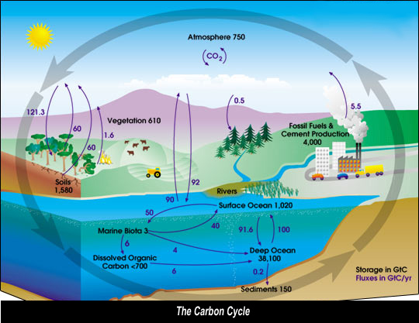

**Pic 1 “The Carbon Cycle”**

So, it is usually hard to breathe in the large cities where there are lots plants. Everything there is covered with soot and dirt.

All these affect harmfully. Every year the atmosphere is polluted by about 1000 tons of industrial dust and other harmful substances. Big cities suffer from smog. Cars with their engine have become the main source of pollution in industrial countries. Vast forests are being cut down for the need of industries in Europe and USA. The loss of the forests upsets the the oxygen balance of the new wastelands. As the result some species of animals, birds, fish and plants have disappeared and keep disappearing.

Water pollution is very serious, too. Ugly rivers of dirty water polluted with factory waste, poisoned fish are all-round us. And polluted air and poisoned water lead to the end of the civilization. So, nowadays a lot of dead lands and lifeless areas have appeared. Because our actions and dealings can turn the land to a desert.

**Global heating**

The greenhouse effect is unquestionably real, and is essential for life on Earth. It is the result of heat absorption by certain gases in the atmosphere (called greenhouse gases because they trap heat) and re-radiation downward of a part of that heat. Without a natural greenhouse effect, the temperature of the Earth would be about zero degrees F (-18°C) instead of its present 57°F (14°C). However, the concern is not with the fact that we have a greenhouse effect, but it is with the question regarding whether human activities are leading to an enhancement of the greenhouse effect **(see Pic 2).**

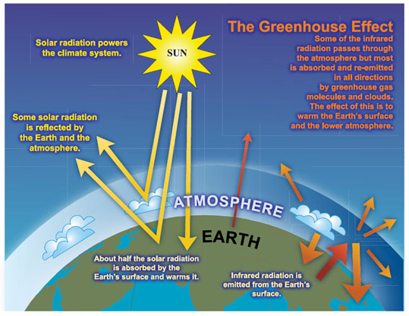

**Pic 2. “The Greenhouse Effect”**

Human activity has been increasing the concentration of greenhouse gases in the atmosphere (mostly carbon dioxide from combustion of coal, oil, and gas; plus a few other trace gases).

Global surface temperatures have increased about 0.6°C (plus or minus 0.2°C) since the late-19th century, and about one half degree F (0.2 to 0.3°C) over the past 25 years (the period with the most credible data).

Some areas (including parts of the southeastern U.S.) have cooled. The recent warmth has been greatest over N. America and Eurasia between 40 and 70°N.

Linear trends can vary greatly depending on the period over which they are computed. Furthermore, there are small unresolved differences between radiosonde and satellite observations of tropospheric temperatures, though both data sources show slight warming trends. If one calculates trends beginning with the commencement of radiosonde data in the 1950s, there is a slight greater warming in the record due to increases in the 1970s. There are statistical and physical reasons (e.g., short record lengths, the transient differential effects of volcanic activity and El Niсo, and boundary layer effects) for expecting differences between recent trends in surface and lower tropospheric temperatures, but the exact causes for the differences are still under investigation (see National Research Council report "Reconciling Observations of Global Temperature Change").

An enhanced greenhouse effect is expected to cause cooling in higher parts of the atmosphere because the increased "blanketing" effect in the lower atmosphere holds in more heat. Cooling of the lower stratosphere (about 30-35,000ft.) since 1979 is shown by both satellite Microwave Sounding Unit and radiosonde data, but is larger in the radiosonde data.

Relatively cool surface and tropospheric temperatures, and a relatively warmer lower stratosphere, were observed in 1992 and 1993, following the 1991 eruption of Mt. Pinatubo. The warming reappeared in 1994. A dramatic global warming, at least partly associated with the record El Niсo, took place in 1998. This warming episode is reflected from the surface to the top of the troposphere.

Indirect indicators of warming such as borehole temperatures, snow cover, and glacier recession data, are in substantial agreement with the more direct indicators of recent warmth.

Arctic sea ice has decreased since 1973, when satellite measurements began but Antarctic sea ice may have increased slightly.

**Ways of the decision of problems of ecology**

The mankind has succeeded in creation of instruments of manufactures and technologies of destruction to itself similar and practically was not engaged in creation of the industry on processing waste products of the activity. In result besides an annual gain of volume of the advanced industrial wastes, including toxic, all over the world there are also old burial places, which number in industrially - the advanced countries is estimated in hundreds thousand, and sizes of volumes of waste products achieve hundreds billions tons. Thus, if to speak about rehabilitation of an environment, having in view of systematic processing waste products (first of all especially dangerous) expenses in hundred billions dollars one year are required during decades.

A number of the countries for a burial place use flooding in the sea (ocean), that, in our opinion, it should be completely forbidden by the international agreements without dependence from a class of danger of waste products.

Actually, to processing of industrial wastes now is exposed no more than 20 % from total amount. Technologies of processing industrial wastes it is possible to classify as follows:

1. thermal technologies;
2. physical and chemical technologies;
3. biotechnologies.

So, we see that our environment offers an abundance of subject matter for discussion. The problems and prospects of the blue planet interest not only scientist and futurologists, but also politicians, industry, the public – and above all, young people! There is hardly a young person who is not conserved with the preservation of our natural habitat. To recognize environmental problems and master them, to reduce and avoid environmental pollution, to discover and develop ecologically sound technologies – there are the essential building blocks for our future.

Whether scientist or politicians, bankers or student, whether Greek, Norwegian, Hungarian or Finn … all are encouraged to make a contribution towards protecting the environment. Dedication and the courage to change one’s way of thinking are called for.

We are to stop pollution. So, we can grow plants and trees, to purify waste, to start urgent campaigns in order to preserve environment For example, in 1989 in Australia, Sydney. In a year the same kind of action was held all over Australia and it was called “Clean up Australia” the following years 110 countries hold the similar actions within the ecological program of the UNO.

Nowadays there are many different pressure and interests groups in many countries, which try to find solutions to the problems of pollution at the national and international level. So they are groups of people with a common interest in trying to draw the public attention to environment problems, to influence the government decisions.

Greenpeace is a very famous pressure group. It started functioning in 1971. Its headquarters are at Amsterdam, but it operates in 25 countries worldwide. The aim of Greenpeace is to protect wildlife of toxic wastes, nuclear tests.

“Friends of the Earth” (FoE) is one of the British pressure groups with an international reputation. Its general aim is to conserve the planet’s resources and reduce pollution. FoE was established in 1971 and now it operated in 44 countries worldwide. It campaigns among other things, for recycling and renewable energy, and the destruction of wildlife and habitat. The main campaigning issues of the FoE are:

* The protection of all animals and plants in danger of extinction.
* An end to the destruction of wildlife and habitats.
* A program of energy conservation measures, etc.

So, a number of campaigns resulted in:

* The ban or other hunting in England and Wales
* And indefinite delay in the construction of the Commercial East Breeder Reactor, etc.

The Baltic Sea is a special case. Because it is such a small sea and it becomes dirty very easily. Its waster changes slowly through the shallow straits. As many as 250 rivers run into the Baltic. There are hundreds of factories in these rivers and millions of people live along them. Quite a lot of big cities lie on its coast. All these combined with the active navigation of the sea naturally affects the state of the sea and the shoreline flora and fauna. People suffer from the water pollution; cancer deaths increase people’s concern. So, global ecological issues influence our planet as you can see on the diagram:

It shows there is no escape from this ecological crisis without organizing a single body dealing with the environmental problems, developing and carrying out a nationwide program of environmental protection and co-operating with international schemes.

**The conclusion**

Scientists now predict that by the year 2050 the population will be doubled what is today. The fact remains that the rate of food production fell behind population growth in many of developing countries. The annual fish catch already exceeds what the world‘s oceans can successfully sustain. If we go on using our natural recourses at today’s rates, we will have used up the entire reserves of cooper, natural gas and oil by the year 2054.

Nevertheless, the problem ahead lie not so much, in what we use but in what we waste. What faces us is not so much a recourse crisis as a pollution crisis. The only solution is to try to change the areas of consumption, technology and population. Changes in technology must be taken by slower population growth. And it can be achieved by education in health and women’s rights. And there is a little hope of reducing consumption over the next half century.

In the conclusion, it would be desirable to tell, that ways of an exit from environmental problems are, it is necessary to see only them and if we shall not make it in the near future all can turn back against us in much more the worse kind, than we even can present ourselves.